HEURISTICS APPROACH FOR ANALYZING THE GEO-DISTRIBUTED DATA
^{1*}S.Sabitha , ²M.Gayathri , ³Dr.S.Nithya kalyani³
^{1*,2} PG scholar/IT , ³ Associate Professor/IT
K.S.R.College of Engineering, Tiruchengode

Abstract:
Big data analytic is and cloud service for analysis useful information.
Traditionally, data sets are stored and processed in a single data center. As the amount of data grows at a high rate, using of one data centre is less efficient to handle large amounts of data and also attaining optimal performance of such system is challenging when compare to traditional system. In order to over such drawbacks, large cloud services are provided to deploy data centers around the world to improve performance and availability. The widely used method for the analysis of geographically distributed data is a centralized approach that aggregates all raw data from a local data center into a central data center. It has been observed that this approach consumes a lot of bandwidth, resulting in poor performance. A number of mechanisms have been projected in literature survey to achieve optimal performance for analyzing data in geographically distributed data center’s. In this paper, heuristics approach for analyzing the geographically data have been proposed and implemented in Hadoop. The result shows that performance of the proposed work is better than existing approaches.
Key words: Big data analytics; Geo-distributed, Data center .

1. INTRODUCTION TO BIG DATA
Big data refers to voluminous amounts of structured or unstructured data that are so large or complex that traditional data processing application software is inadequate to deal with them. Big data spends 70% of the time on gathering and retrieving the data and remaining 30% of the time is spend on analyzing the data. Big data can process even several peta bytes of data in seconds.
1.1 Characteristics of Big data
There are three characteristics of big data namely volume, velocity and variety. The characteristics are explained in detail below.
- Volume
Many factors contribute to the increase in data volume. Volume refers to the sense of storage in Big data.

- Velocity
Data is streaming in at unprecedented speed and must be dealt with in a timely manner. Velocity refers to speed and performance of Big data.
- Variety
Data today comes in all types of formats. Variety refers to the types of data used in Big data.

Structured data refers to numeric data in traditional database. Unstructured data refers to text documentation, email, video, audio etc.
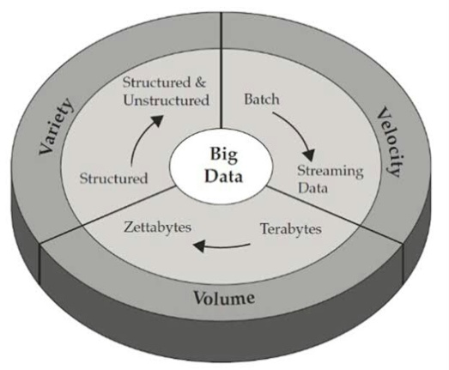
Figure 1.1: Characteristics of Big data
1.2 NEED FOR BIG DATA:
In Data Warehousing and Data Mining storing the data, analyzing the data processing the data and managing the data cannot be done in parallel. It cannot handle both structured and unstructured data at a time. Data Warehousing and Data Mining spend 95% of the time on gathering and retrieving the data and only 5% of the time is spend for analyzing the data. But in real time scenario, we are in a situation to analyze each and every data. We are generating data faster than ever, so the need for Big data emerged. In Big data 70% of the time is spend on gathering and retrieving the data and remaining 30% of the time is spend on analyzing the data.
1.3 HADOOP
Hadoop is the most popular open source framework used in Big data to handle large dataset. It is the batch oriented system. Hadoop is used to analyze user interaction data. It is linear scalable low cost commodity hardware. It is designed to parallelize data processing across computing nodes to speed computations and hide latency.

1.3.1 Hadoop Architecture

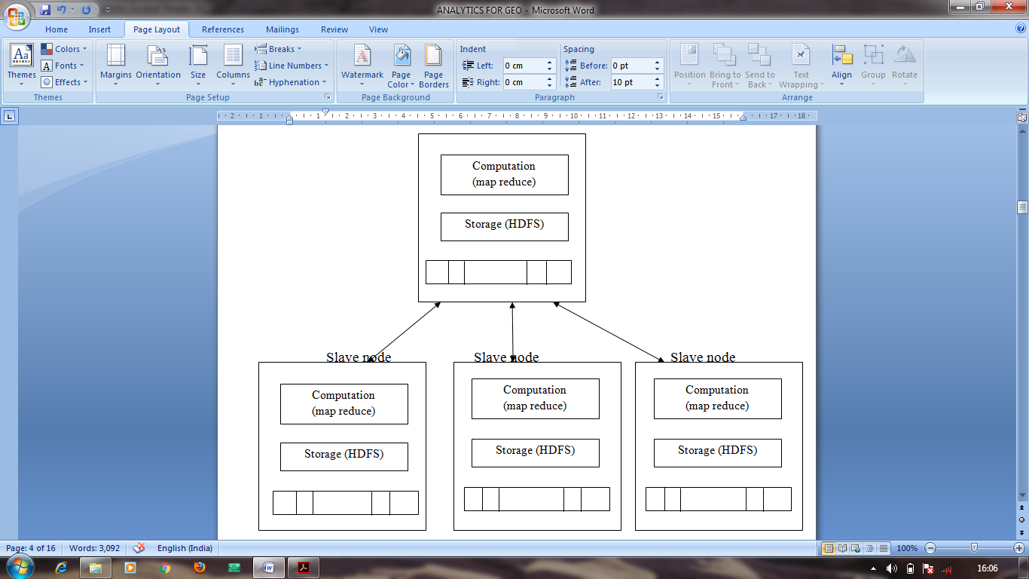
Figure 1.2: Hadoop Architecture
The architecture of Hadoop consists of one master node many slave nodes. In the master node their will be a MapReduce model which is used for computational purpose and a Hadoop Distributed File System (HDFS) which is used to store large amount of data. Also in each slave node their will be a MapReduce as well as HDFS.
1.3.2 Core Hadoop Components

1.3.2.1 HDFS
HDFS is the storage components of Hadoop. It is optimized for high throughput and works best when reading and writing large files. HDFS replicates files for a configured number of times, is tolerant of both software and hardware and automatically re-replicates data blocks on nodes that have failed. The blocks are replicated to node throughout the cluster based on replication factor (default is 3).Replications increases reliability and performance. There are three daemons in classical HDFS.
- NameNode (Master)
- Secondary NameNode (Master)
- Data Node (slave)

- NameNode
The NameNode manages the file system namespace. It maintains the file system and the metadata for all the files. This information is stored persistently on the local disk in the form of two files: the namespace image and the edit log.

- Secondary NameNode
Secondary NameNode does not act as a name node. Its main role is to periodically merge the namespace image with the edit log to prevent the edit log from becoming too large. The Secondary NameNode usually runs on a separate physical machine, since it requires plenty of CPU and as much memory as the name node to perform the merge.
- Data Node
Data Nodes of the workhorses of the file system. The actual contents of the file are stored as blocks. They store and retrieve blocks and they report back to the name node periodically with lists of blocks that they are storing. Data Nodes must send block reports to both name nodes since the block mappings are stored in a name node’s memory and not on disk.
1.3.2.2 MapReduce
MapReduce is a software framework for processing large datasets in a distributed fashion over several machines. The core idea behind MapReduce is mapping the dataset into collection of key/value pair and then reducing all pairs with same key.
- Map Step
The master node takes the input, divides it into smaller sub-problems and distributes them to worker nodes. A worker node processes the smaller problem and passes the answer back to its master node.
- Reduce Step
The master node collects the answer to all the sub-problems and combines them in some way to form the output.
MapReduce is as a 5-step parallel and distributed computation:
1. Prepare the Map () input.
2. Run the user-provided Map() code.
3. “Shuffle” the Map output to the Reduce processors.
4. Run the user- provided Reduce() code.
5. Produce the final output

1.3.3 Advantages of Hadoop
The advantages of Apache Hadoop are as follows:
1. Hadoop is cheap.
2. Hadoop is Fast.
3. Hadoop scales to large amount of Big data storage.
4. Hadoop scales to large amount of Big data computation.
5. Hadoop is flexible with types of Big data.
6. Hadoop is flexible with programming languages.

1.4 DATA CENTER
A data center is a facility composed of networked computers and storage that business or other organizations used to organize, process, store and disseminate large amounts of data. Data centers are physical or virtual infrastructure. Data centers serve as the principal repositories for all manner of IT equipment, including servers, storage subsystems, networking switches, routers and firewalls. It provides cabling and physical racks to organize and interconnect IT equipment. Communications in data centers are based on networks running IP protocol suite. Data center contains a set of routers and switches that transport traffic between the servers and to the outside world.
Figure 1.4: Data center
1.4.1 Need for data centers
Despite the fact that hardware is constantly getting smaller, faster and more powerful, the demand for processing power, storage space and information in general is growing and constantly threatening to outstrip companies’ abilities to deliver. Any entity that generates or uses data has the need for data centers on some level, including government agencies, educational bodies, telecommunication companies, financial institutions, retailers of all sizes and social networking services such as Google and Face book. Lack of fast and reliable access to data can mean an inability to provide vital services or loss of customer satisfaction and revenue. Data center ensures the reliability and access of the mission-critical information contain within the data center’s storage. It also entails efficiently placing application workloads on the most cost-effective compute resource available.
1.4.2 Advantages of Data center

- Numerous cost benefits and time gained for core activities.
- A valuable option for companies to access cutting-edge tools and technology such as blade severs, Flywheel UPS systems,etc.
- Adaptability to varying business situations
- Improved flexibility to choose specific data center related metrics.
- It provides unique, client-centric solutions such as cloud computing, real-time lookup, etc.
- Making full use of in-house IT potential and human resources.
- Legal and other regulatory compliances are generally taken care of by data center providers
- Expansion into offshore markets and other scalability measures made possible
- Single-tenant facilities ensure enhanced security management along with other DCIM solutions

2. EXISTING SYSTEM
Even if the company does not have budget problems, the capacity of the data center's internal WAN will not grow at the same rate as the amount of data to be analyzed, and that such a solution will not be sustainable over the long term. Finally, it takes time to migrate all the data to a data center, and the longer it takes, the worse the performance.
3. PROPOSED SYSTEM
Increasing the amount of data, storing such data in the same data center is no longer viable, and they naturally need to be distributed across multiple data centers. This is further inspired by the fact that the data to be processed, such as the user activity log, is generated in a geographically distributed manner. It is more efficient to store data in the location where data is generated. Apache Hive is the data warehouse infrastructure used to query and analyze data in distributed storage. The solution is exciting and highly relevant and may soon be applied to real-world data analysis applications. We first briefly introduce the background of the batch and stream processing framework.
Batch processing framework is used to handle the data which compute big and complex data and more concerned with throughput. When a short response time is not strictly required, batch processing is a widely used way to process considerable volumes of data without any user intervention. It takes large dataset input all at once, process it and write a large output. For batch processing, input data is collected beforehand and then processed in batches.
Hadoop MapReduce, a software framework for distributed processing is used to schedule the task. It split the input dataset into independent chunks. It has three major processing phases: Map, Shuffle and Reduce. MapReduce allows processing a substantial amount of data in parallel by using key/value pairs. Heuristic algorithm is used to compare the result and find best solution among possible ones.
4. PROJECT DISCRIPTION
4.1 OVERVIEW OF THE PROJECT

Big data analytics is primarily used to organize analyze data to get useful information. The data centers are geographically distributed around the world. To increase the performance, the data are processed in the local data centers and moved towards the central server where data is stored in Hadoop Distributed File System (HDFS).

Apache Hive is the data warehouse infrastructure used to query and analyze data in distributed storage. Batch processing framework is used to handle the data which compute big and complex data and more concerned with throughput. Hadoop MapReduce, a software framework for distributed processing is used to schedule the task. It split the input dataset into independent chunks.

Heuristic algorithm is used to compare the result and find best solution among possible ones. The output is shown in the console in different forms of graphs such as Line chart, Bar chart, 3D D” hunt and Pie chart.
4.2 SYSTEM DESIGN:
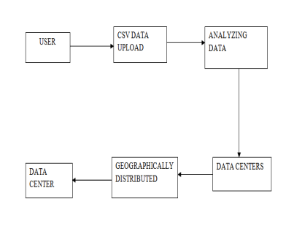
Figure 4.1: System design
4.2.1 USER
The user who is a admin logins in the system and uploads and the dataset which is a collection of records similar to relational database. If the user is not a admin, then he can view the processed output in the console.
4.2.2 CSV DATA UPLOAD
CSV is file extension of .csv which means comma separated values. It is a container for database information organized as field separated links. A .csv file stores tabular data in plain text. Each record consists of one or more fields, separated by commas. The use of the comma as a field separator is the source of the name for this file format. The admin uploads dataset which is created in .csv format.
4.2.3 ANALYZING DATA
The uploaded data is analyzed using batch processing framework which process the input data by splitting the input data into batches. MapReduce, a software framework for distributed processing is used to schedule the task. It split the input dataset into independent chunks and process the data.

4.2.3 DATA CENTERS
The analyzed data is stored in the central server where the data is stored temporarily and then distributed among the datacenters.

4.2.4 GEOGRAPHICALLY DISTRIBUTED
The data are distributed to data centers around the world so that the information can be viewed from anywhere across the world.
4.2.5 DATA CENTER
The analyzed data are displayed in different forms of graphs such as Line chart, Bar chart, 3D D” hunt and Pie chart.
4.3 MODULE DESCRIPTION
4.3.1 BATCH PROCESSING FRAMEWORKS
Hadoop is a batch processing framework and data to be processed are stored in the HDFS, a powerful tool designed to manage large datasets with high fault-tolerance. Map Reduce, the heart of Hadoop, is a programming model that allows processing a substantial amount of data in parallel. It has three major processing phases: Map, Shuffle, and Reduce. Traditional relational database organizes data into rows and columns and stores the data in tables. Map Reduce uses a different way, it uses key/value pairs. The Map function performs sorting and filtering by keys, and then shuffles the intermediate results to the downstream operators which perform reduce tasks. The Reduce function applies summary operations on the intermediate data generated by Map.
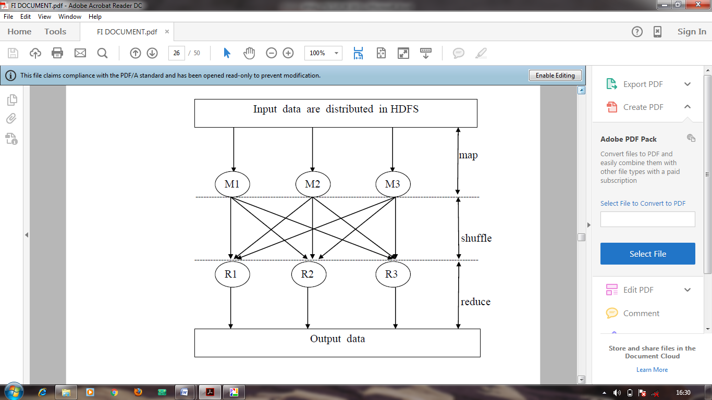
Figure 5.2: Process of MapReduce
4.3.2 MECHANISMS FOR WIDE AREA ANALYTICS:
Figure 2.2 : Working of Heuristic algorithm
Distributed execution is a strategy widely used in the wide area analytics. This strategy is to push computations down to local datacenters and then aggregate the intermediate results to do further processing. Batch processing framework is used to handle the data which compute big and complex data and more concerned with throughput. Hadoop MapReduce, a software framework for distributed processing is used to schedule the task. It split the input dataset into independent chunks. Heuristic algorithm is used to compare the result and find best solution among possible ones. It find a solution close to the best one and they find it fast and easily.

4.3.3 DISCUSSION OF EXISTING MECHANISMS:

Analytics for geo-distributed datacenters in the wide area network have several aspects. Some mechanisms are batch processing, some are stream processing. Bandwidth and latency are two important optimization issues we consider in the wide area analytics. WANalytics and Geode use a workload optimizer to find the best distributed execution plan. However, sometimes it may be slow for the workload optimizer to give the best execution strategy. Moreover, arbitrary queries are allowed on the data, which does not consider data movement constraints.

4.3.4 PERFORMANCE EVOLUTION:
Pixida:
When a job is submitted for execution, we can get the job’s task-level graph and locations of input data partitions from distributed storage systems like HDFS. Thus the data traffic minimization problem can be translated into the graph partitioning problem, where the job’s task-level graph is split into partitions, each partition contains the tasks in the same datacenter.

Pseudo-distributed measurement:
Similar as the Tracer phase in Pixida, Pseudo-distributed measurement is used to measure the cost of each execution strategy for a DAG. For some settings, measuring all options considered by the greedy heuristics could be very slow, which is a limitation for this measurement.

4.3.5 REPORT GENERATION:

As data grows at a tremendous rate, achieving optimal performance in the wide area analytics becomes more and more challengeable. Compared with the local network in a datacenter, the WAN covers a relatively broad geographical area, which is more complicated and unstable. Moreover, processing a substantial amount of data within a very small time interval is a great challenge for those low latency cloud applications. In this paper, we present a number of typical mechanisms in the wide area analytics, discuss high-level ideas, and give a comparison of these mechanisms. Although with some limitations, more effective solutions may be inspired by these mechanisms and applied in the real world in the near future.

Figure 4.3: Output graph

5. CONCLUSION AND FUTURE ENHANCEMENT

As data grows at a high rate, achieving optimal performance in wide area analysis is becoming increasingly challenging. Compared to the local network in the data center, the WAN covers a relatively wide geographical area, which is more complex and unstable. In addition, dealing with large amounts of data in very small time intervals is a huge challenge for low-latency cloud applications. In this paper, we present some typical mechanisms for wide area analysis, discuss high-level ideas, and give a comparison of these mechanisms. While there are some limitations, more effective solutions may be inspired by these mechanisms and will be used in the near future in the real world.

6. REFERENCES

1. K. Kloudas, M. Mamede, N. Preguic¸a, and R. Rodrigues, Pixida: Optimizing data parallel jobs in bandwidth-skewed environments, VLDB Endowment, vol. 9, no. 2, pp. 72–83, 2015.

2. A. Vulimiri, C. Curino, P. Godfrey, T. Jungblut, J. Padhye, and G. Varghese, Global analytics in the face of bandwidth and regulatory constraints, in Proc. Of USENIX Symposium on Networked Systems Design and Implementation (NSDI), 2015.

3. K. Shvachko, H. Kuang, S. Radia, and R. Chansler, The Hadoop distributed file system, in Proc. of IEEE on Mass Storage Systems and Technologies (MSST), 2010.

4. J. Dean and S. Ghemawat, Map Reduce: Simplified data processing on large clusters, Communications of the ACM, vol. 51, no. 1, pp. 107–113, 2008.

5. M. Zaharia, M. Chowdhury, T. Das, A. Dave, J. Ma, M. McCauley, M. J. Franklin, S. Shenker, and I. Stoica, Resilient distributed datasets: A fault-tolerant abstraction for in-memory cluster computing, in Proc. Of USENIX Symposium on Networked Systems Design and Implementation (NSDI), 2012.

